
October 2010 Volume IV, No. 4
Among Friends

WELCOME,  NEW MEMBERS  Janice Bahary  Helene Bender & Mark Heine  Ken Boas  Eleanor Craig  Lauren Dahl  Betsy DellaVecchia  Robert Gallagher  Dina Guseva  Leo Hsu  Alan & Laura Irvine  Charlene Jones  Miriam Lucarell  Gayle Mallinger  Tom & Barb Manion  Keaton Manion  Makayla Manion  Chris Markwell  Marcel Minutolo  Maria Mor  Maria Pedro  Susan Peebles  Michael Rieder  Elayne Salzman  Judith Silan  Gaven Silvio  Owen Silvio  Lanoma Stein  Joe Titlebaum  Olivia Wells  Evelyn Whitehill  Join us at our regular  Friends Meetings  Saturdays at 10 AM  October 9th  November 6th  December 4th    all are welcome | cautionary tale for our readers.  I’m writing this from a rehabilitation facility, where I am recovering from a lengthy hospital stay, originating from an undiagnosed case of shingles. One thing led to another…and here I am. Shingles are incredibly painful and can last for months. Fortunately, my case was mild because three years ago, I had a shingles vaccination. But I incorrectly assumed – as did my many physicians – that the vaccination meant complete immunity. Because of this assumption, the shingles were undiagnosed until they started appearing on the outside of my skin, many days and many tests later. Luckily, the vaccination and anti-viral medication did result in a milder case, but if I had known that it was still possible to get shingles after a vaccination, a lot of pain and expense could have been avoided.  So I have two recommendations for you, dear reader. First, talk with your physician about whether or not a shingles vaccination is appropriate for you (i.e. age, history of chicken pox). Second, if you do get the vaccination, do not eliminate shingles as a possible cause of pain or other symptoms. If this advice prevents any of you from suffering from shingles, this column will have achieved its purpose.
  PRESIDENT’S  MESSAGE  by Joan Schwartzman  When you read a library newsletter, you don’t expect it to be a source  of medical advice. But this column turns out to be just that – a true, | 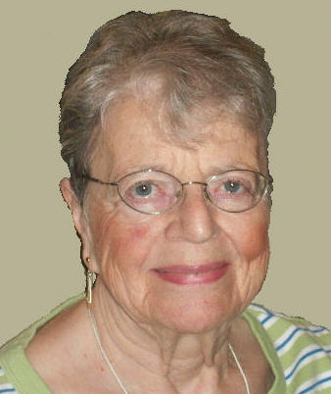
This will never be a civilized country until we expend more money for books
than we do for chewing gum. Elbert Hubbard

Final Community Input Meeting held at Squirrel Hill:
CLP Warns of Major Cuts For 2011

On September 19, in spite of it being a Steeler Sunday, a standing-room-only crowd of 125 library enthusiasts met at Squirrel Hill with CEO Barbara Mistick, other library staff, and Board members to discuss the results of previous community input sessions and possible alternatives for coping with library deficits next year and beyond.

Deputy Director Mary Frances Cooper said that the public/private task force to find sustainable funding does not expect any solution(s) until 2012 at the earliest. For 2011, there is a budget gap of $1.7 million. Although the CLP Board will not close any branches, major cuts will be needed unless the city and/or RAD step in with emergency funding. Following what they learned from those attending two previous rounds of meetings, CLP plans to control expenses by: cutting hours at each branch the equivalent of one day per week; cutting the number of computers by 40%; and stopping almost all outreach and adult programming. In addition, additions to the collection will be reduced from 13.3% of the budget to 12%, the minimum to qualify for state aid.

Small groups were formed to discuss what they wouldn't cut, what might be cut, and where to find the funds, then report their ideas. Suggestions included: keep outreach programs for children and teens; put pressure on elected officials; set up places for donations from public all over; consider religious practices in choosing what days to close; vary times and days at different branches, so if one is closed, a nearby one is open; keep branches open near senior centers; advertise need for volunteers in libraries. It was clear that everyone desperately wants/needs libraries to continue as much as possible. –by Dean Damick with
contributions by Marion Damick
For more facts, an action plan, and a link to much more, see page 3.

Published quarterly by the Friends of the Squirrel Hill Library, 5801 Forbes Avenue, Pittsburgh, PA 15217
website: www.carnegielibrary.org/locations/squirrelhill e-mail: Friends@pittsburghusedbooks.com
editor: Joan Schwartzman production: Margie Spenser, Marion Damick,
mailing list: Margie Spenser Dean Damick, Leigh Anne Vrabel, Serena Spenser

October 2010 Among Friends Volume IV, No. 4

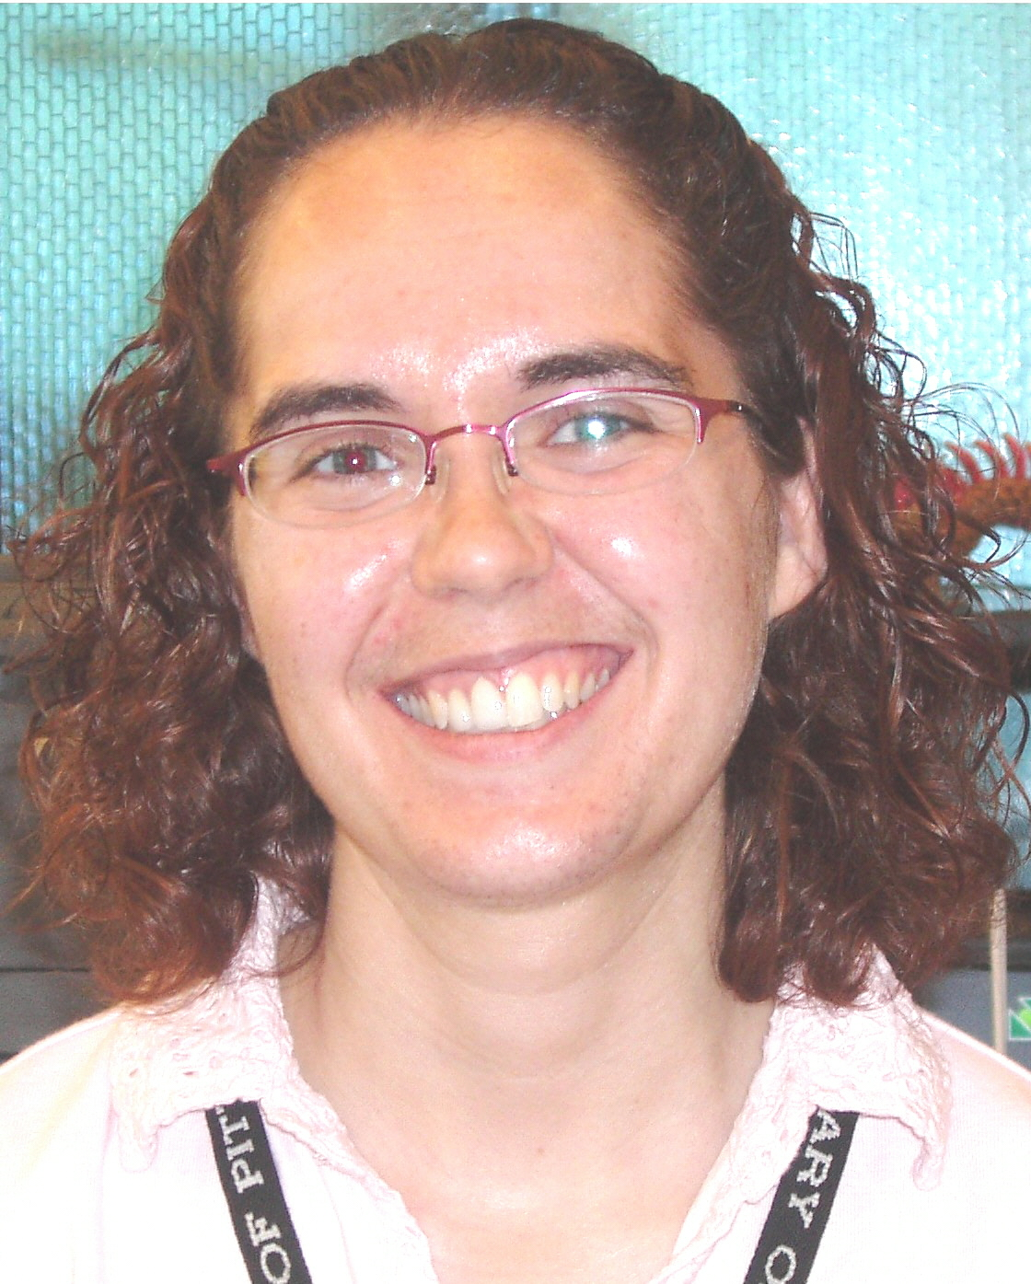  Megan Fogt  Manager of  Children’s Services | Get a Little Loud in the Children’s Room!  Literacy is a little loud at our library. Whether we are singing songs with babies,  encouraging toddlers to use shakers to hear the syllables in Mother Goose rhymes, or  acting out stories with elementary kids, we are always looking for fun (and yes, often  noisy) ways to promote reading. So during the month of September, we took a  programming sabbatical to catch a few quiet moments to plan new library programs,  organize and adjust our collections, and schedule visits to daycares and preschools for the  school year.
During September, we also took time to celebrate our successful Summer Reading Club. We had over 1,000 kids sign up for our Summer Reading Club this year! This is a significant increase over the last few years. We are pleased to be able to encourage so many kids to keep reading over the summer. If you were in our library this summer, you would have seen lots of excited children telling us about what books they have read this summer and getting prizes.

We are particularly proud of our work to support reading over the summer, in light of a new research study done by The University of Tennessee. Researchers Richard Allington and Anne McGill-Frazen have completed a three year study that found that reading over the summer might be even more useful – and cheaper – than summer school to help children achieve better during the school year.

One of the metaphors used in this research study is particularly meaningful in our sports-focused city. Richard Allington states: “Just like hockey players lose some of their skills if they stay off their skates and off the ice for three months, children who do not read in the summer lose two to three months of reading development.” We are pleased that our library helps keep our kids in good reading shape all year long!
For more information, check out: http://www.goodreads.com/review/show/79627614

Even though we appreciate the slightly quieter atmosphere during our programming sabbaticals, we can’t wait for the louder, bustling chaos of our programming season. So, we are glad to be back to programming in October. We would love to have you join us as we celebrate literacy for all ages at these regular programs:
- Family Storytime Saturdays at 11:00 AM
- Baby and Me Thursdays at 10:30 AM and 11:30 AM
- Toddler Storytime Tuesdays at 10:30 AM and 11:30 AM
- Preschool Storytime Mondays at 1:00 PM
And check out more fun programs on our website at http://www.carnegielibrary.org/kids/happening/.

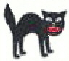

Take your Halloween costume out for a test drive on Monday, October 25th at 6:00 PM
for our annual Halloween party!
Join us for stories, songs, crafts, and more to help everyone get into the Halloween spirit.
For ghosts and goblins up to age 8 and their families.
Have you met our new full-time librarian, Debbie Priore? Debbie has worked in the Carnegie Library system for over thirty years in a variety of departments. With the arrival of four children, the past sixteen years have been part time, primarily in the Children’s Department at Main. Since November, she has worked at Squirrel Hill part time, in addition to Main, filling in as needed. She has had a wonderful time working with and learning from our dedicated, talented, and enthusiastic staff. She couldn’t be more thrilled to return to full-time status in a library that celebrates community and family.  Three fun facts about our new full-time children’s librarian:  1. She started out her career at the Carnegie Library of Pittsburgh as an artist.  2. During the summer she and her family rear butterflies. This year they raised Luna Moths,  Red Admirals, and Monarchs.  3. She has an extensive puppet collection and likes to make them talk to staff and customers.  Be careful about reading health books.  You may die of a misprint. Mark Twain |  | 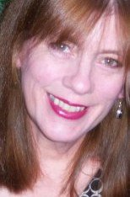
2

October 2010 Among Friends Volume IV, No. 4
 |  | NAMM BUSINESS CENTER PROGRAMS  October – December 2010  by Dorothy Kabakeris, Namm Business Center Librarian  All programs are scheduled for Wednesday  from 10:15 AM – 11:00 AM | 

Oct 13 Dining Etiquette
Command new confidence at your next business lunch
with your boss or your prospective boss.
Presented by Karen Litzinger, Litzinger Career Counseling.
Oct 20 Thinking about starting your own business?
Realities and advice for the new entrepreneur.
Joyce Pearl, SCORE counselor.
Nov 10 & 17 Seminars for Job Seekers
Presented by Dawn Zuckerman, MSW, Employment Specialist
Nov 10 – Find out the key points in a winning resume
with online application tips.
Nov 17 – Plan a successful interview with mock interviews
illustrating do’s and don’t’s.

Also in Ms. Zuckerman will offer free one-on-one 45-minute resume
November and interview counseling sessions for job seekers.
Please call us at 412-422-9650 to schedule a personal session.
Dec 8 Learn how to get free authoritative answers
to many legal questions on the Internet
and at the Allegheny County Law Library.
Presented by Joel Fishman, Ph.D.,
Assistant Director, Allegheny County Law Library
The Squirrel Hill Adult  Book Discussion Group  All are Welcome.  Thursday, October 28 1:00 PM  Balzac and the Little Chinese  Seamstress (fiction)  by Dai Sijie, 2002  November – no meeting  Thursday, December 9 1:00 PM  The Places in Between  by Rory Stewart, 2006  The monthly Namm newsletter lists our business programs and new business titles. To have it sent to your computer,  email us at:  squirrelhill@carnegielibrary.org | Life is not easy for any of us. But what of that?  We must have perseverance and above all confidence in ourselves.  We must believe we are gifted for something.  Marie Curie
 | Special Book talk:  Wednesday, October 20, 2010 @ 1:00 PM  Lu Donnelly, Pittsburgh architectural historian, will talk about her new book, Buildings of Pennsylvania: Pittsburgh and Western Pennsylvania, University of Virginia Press, 2009. A book signing will follow. | 
Timeline for Decisions on 2011 Budget
Sep 30: Allegheny Regional Asset District (RAD) Preliminary 2011 Budget Release
Oct 18: Library Board meeting, Task Force update; preview options for the future
Oct 26: RAD Public Hearing on Budget
Nov 8: Mayor’s Budget Address
Nov 30: RAD Final 2011 Budget Adoption
Late Nov/early Dec: Library Budget hearing before Pittsburgh City Council
Mid-Dec: City Council adopts 2011 Budget
Dec 13: Library Board meeting, 2011 Budget Adoption; Task Force Recommendation

What can you do? Write a letter to the Editor! Contact any elected or appointed official you know and tell them how important the library is to you. Come to the public hearings and tell officials why the library is important to you. Get your neighbors and friends to write and to come with you.

See the rest of the document this came from, the DISCUSSION GUIDE (Part 3) for the Community Conversations, at www.carnegielibrary.org/future. It’s full of details and numbers.
3
3
October 2010 Among Friends Volume IV, No. 4

 |  | . Looking into my crystal ball  By Holly McCullough, Manager, Carnegie Library of Pittsburgh – Squirrel Hill  I’m hoping that by the time you’re reading this you will have: attended one of the last of the community meetings held in September; read the discussion guide; and offered your thoughts
and opinions on the future of the library. I’m hoping that this information has inspired you to step up your efforts as Friends, Donors, Advocates, and Volunteers of the library. I’m hoping that by now the RAD board has presented its preliminary budget and has provided the library with the emergency stopgap funding we need to get through another year without severe cuts. I’m hoping that the library’s public/private task force has found a potential solution to our long-term funding issues that will enable us to be the library that this community wants and deserves. I’m hoping that right now this article is serving as another in a long-line of “thank you” notes for all of your efforts to save your library and that we’re in the midst of planning a push to make that potential long-term solution a reality.

If perhaps my admittedly optimistic hopes haven’t been fully realized, then I’m probably spending my time managing the drastic changes to come next year. I will be figuring out how to lay off one or more of my staff (perhaps one of the faces smiling at you from this very newsletter). I’ll be figuring out what days and hours to cut when every day and moment is busy here in Squirrel Hill and there is such desperate need for our services. I’ll be thinking about the kids that we won’t be reaching in their pre-schools and daycares and the impact that will have on their emerging literacy skills. I’ll be estimating the increase in the length of time for everyone to get their requested books and DVDs when we have to buy less. I’ll be thinking about how to find enough time on the computers for people to do things like apply for jobs and file for unemployment, when we go from sharing 40 public computers to only 26.

That second vision is a bleak one, but instead of dwelling on it, I’m actively working against it. I can’t predict the future. I can’t control what will happen or what people will do. I can only control my own actions and hope that my actions influence the present and the future in a positive way. If the work I’m doing now as I write this hasn’t had the effect I would have liked, if I haven’t been successful enough in encouraging people to recognize that the library is their responsibility, then all I can do is keep trying and working and hope that this appeal, written a few weeks into the future, will do what I couldn’t do then. I can predict that I won’t give up hope. I’ve seen the results of our efforts. I’ve seen people like Margie and Joan and Marion and Pat and Eleanor and many many more do their parts to keep our libraries open last year. I believe we can do it again. I believe we can, and will, do it as long as we have to. What other choice do we have?

If you’d like to do your part in realizing the best possible present and future for our libraries, please contact me now at or 412-422-9650.
 | Art  at the  Squirrel Hill Library |  | BOOKS,BOOKS,BOOKS,BOOKS,BOOKS,BOOKS  by Margie Spenser, Book Sale Committee  The Fall Clearance Book Sale (Oct 29-Nov 1) is our chance to clean out our store-room and start over. We invite nonprofit organizations to come on Bag Day to  select free books. Tell me about your group by October 20th so I can send you  “Free Bags” name tags for up to three representatives. Write me at margie @pittsburghusedbooks.com or call 412-521-4129. | 
Coming up are:  October: Nancy Arnold  abstracts  November: Frank DiPietro  photos  December: Keith Chiopo  photos  Our schedule is full through March, 2012.  To exhibit after that, contact Marion Damick,  412-521-3075. |  |  | There’s been a marvelous response to our request for empty copy-paper boxes. Thanks to Rose at Northwood Realty, who said she had 4, but had 6 by the time I got there to pick them up; to Rita Motor, who brings us a steady stream of boxes from CMU; to Lucy Newman, who told her dad, who told Children’s Hospital (they have 10 waiting for me); to the Friend who left a message yesterday that she has 4 boxes I can come get at Pitt, and will tell her friends to save theirs; and to all of you who bring them in anonymously. Don’t stop! Last week we actually were able to recycle two old ones that had gotten so limp that no quantity of U-Haul box tape could keep their sides straight.  I’m still looking for Epson ink cartridges, series T060xx and T069xx. We save tons of money on the newsletter because I refill cartridges, so we can use old ones as well as full ones. Someone brought us two large cartons of unopened Epson and Canon compatible “carts”; thank you, whoever you are. The ones I can’t use will be for sale at our Flea Market during the October book sale. For a list, go to www.pitts burghusedbooks.com and click on FRIENDS, then INK.  Our library staff is working extra hard, since two people have left and not been replaced. I never saw any of them loaf before, and I can’t imagine how they are managing to keep up now. There are tasks that can be done by volunteers; call Audrey Hines at 412-422-9650. Even a few hours a week can make a difference.  We are eagerly awaiting Joan’s recovery!  4
  We are eagerly awaiting  44 | Joan’s recovery!  4

October 2010 Among Friends Volume IV, No. 4
 | Film, Fiction, Fun  third Thursday  of the month  from 1 to 4 PM  lead by Jeanne Bergad

October 21
Raise the Red Lantern
November 18
One Flew Over the Cuckoo’s Nest
December 17
The Adventures of Huckleberry Finn

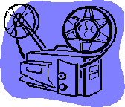 | Film,  Fiction,  Fun  by Mark Russell, Librarian | 

Film, Fiction, and Fun is a special series presented at the Carnegie Library of Pittsburgh – Squirrel Hill that explores the relationship between films and the novels that inspired them. Attendees are encouraged to read a monthly fiction selection, and then join CCAC’s Jeanne Bergad for a screening of the film and discussion to follow.

October 21st’s title is Raise the Red Lantern by Su Tong. Originally titled Wives and Concubines, this novel is set in 1930s China, and tells the story of Lotus, a young college student who becomes a concubine in the wealthy Chen household after her father’s business goes bankrupt and he commits suicide. Lotus finds herself in competition with three other concubines, and she becomes immersed in household intrigues. The 1991 film, starring Li Gong, was nominated for the Academy Award for best foreign film, and although it did not win the Oscar, it picked up the best foreign film award from many critics’ organizations, including the New York, Los Angeles, and London film critics’ circles.

November 18th’s novel is One Flew Over the Cuckoo’s Nest by Ken Kesey. Based on Kesey’s own experiences working the graveyard shift in a mental institution, this 1962 book portrays the bleak lives of patients in an Oregon asylum. The institution is run by the tyrannical Nurse Ratched, whose authority is threatened by a new patient, the free-spirited convict Randle McMurphy. McMurphy becomes the head nurse’s chief antagonist, and his defiance inspires the other patients to stand up for themselves. The 1975 film starred Jack Nicholson as McMurphy and Louise Fletcher as Nurse Ratched, and both won Oscars for their performances. The film also took home Oscars for best adapted screenplay, best picture, and a best director award for Milos Forman.

December 16th’s title is The Adventures of Huckleberry Finn by Mark Twain. First published in 1884, this work is one of the first American novels written in the vernacular. It’s a classic tale of the search for freedom, undertaken by the title character, a young Missouri boy, and his friend Jim, an escaped slave. As Huck and Jim travel the Mississippi river by raft, they experience an American odyssey of sorts, encountering steamboats, family feuds, and con men. There are several film versions of The Adventures of Huckleberry Finn. The 1993 version, directed by Stephen Sommers, features Elijah Wood in the role of Huck. Eight years later, Wood would star in an another adaptation of an epic literary journey, as Frodo Baggins in The Lord of the Rings.

When I am attacked by gloomy thoughts, nothing helps me so much as running to my books.
They quickly absorb me, and banish the clouds from my mind.
Michel de Montaigne 1523 – 1592
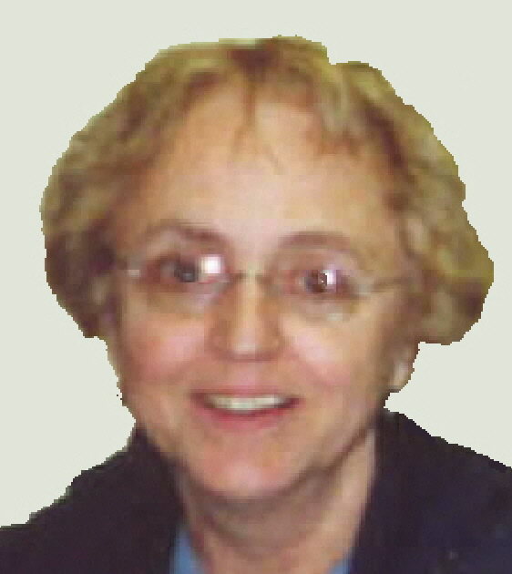 | MINI SALE NEWS  by Pat Bender, mini-sale chair  We had a good time at the July Sidewalk Sale. There was wonderful interest in the boutique and it earned $400 from sales. It was very gratifying and all proceeds go to the Library.  The September mini sale brought in about $400. It featured a huge stock of Judaica, along with books on other religions and philosophies. Books we didn’t sell will be joined by others in the
ongoing sale and at October’s sale. During the September sale, we learned about another you should check out: see page 6.

During the October Book Sale, which will be held by Margie and crew in the main meeting room as always, there will be a Flea Market in the hall outside the main room. We are requesting donations of small items in good condition for the sale.
The November Holiday Mini-Sale will feature many, many special books. We have been putting aside like-new books since last year's sale; our stock is huge. Our "Plain Brown Wrapper" section will feature donations of adult material appropriately covered and discreetly displayed. The children's section will include many foreign language books that were donated several months ago. Opening that donation was a very special experience. Also, we hope that the Boutique will prompt you to start your holiday shopping.

We have a lot to look forward to!
5

CARNEGIE LIBRARY OF  PITTSBURGH – SQUIRREL HILL 5801 Forbes Avenue  Pittsburgh, PA 15217  Adult Services: 412-422-9650  Children's Services: 412-422-9841  Fax: 412-422-5811  www.carnegielibrary.org/clp/sq  Is your Friends Membership up to date? Please check your mailing label/membership card. ➔  If the date is before 10/10, you need to renew. Mail us the form below. | ADDRESS SERVICE REQUESTED  your donation is tax deductible as a charitable contribution | 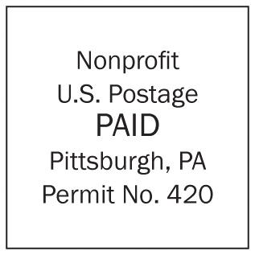  Copies of the newsletter distributed at the library may have printer errors.  To receive your own  better copy at the  beginning of each quarter, join the Friends of the Library by mailing us the form below, or leaving it  at the Customer Service desk.
  
  «exptext»  «expdate»  EXPIRES:  MONTH YYYY | «first» «last»  «addr»  Pittsburgh, PA «zip» «zip2» NAME  ADDRESS  CITY, ST

page is printed – no changes possible

October 2010 Among Friends Volume IV, No. 4

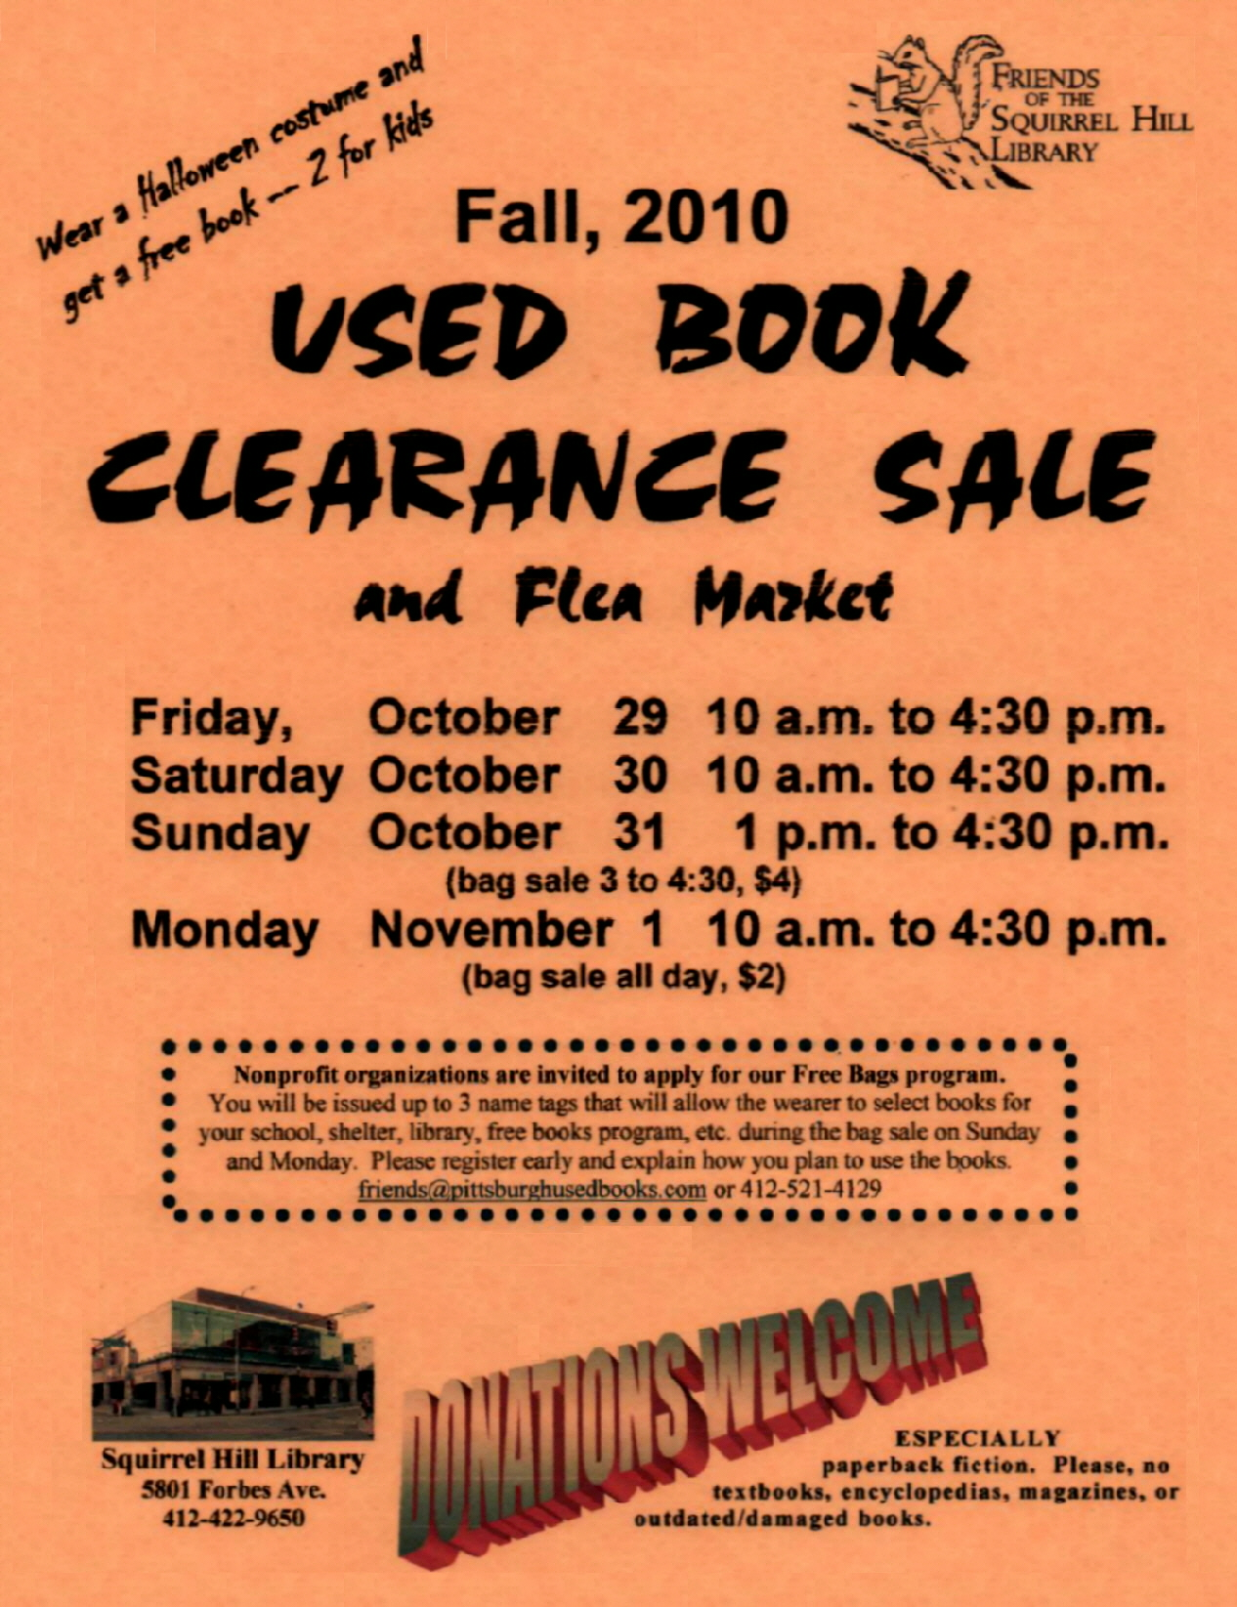  To acquire the habit of reading is to construct for yourself a refuge from almost all the miseries of life.  W. Somerset Maugham  Wanted to buy: Coming out of  the Ice, by Victor Herman. margie@pittsburghusedbooks.com | make checks payable to:  Friends of the Squirrel Hill Library  and mail to:  Margie Spenser  5900 Douglas St  Pittsburgh, PA 15217  Check one box:  New Member Renewal  Check one OR two boxes:  $5.00 $10.00 $15.00  $25.00 Other___ DONOR (free)  Name: _____________________________________  ^{(Last)} ^{(First)}  Address: ___________________________________  City/State: ___________________Zip: ___________  Phone(s): ___________________Date: ___________  E-mail address: ______________________________  Please check all activities you can help with:  Periodic Book Sales Sorting Used Books  Adopt-a-Shelf Program Gardening  Library Advocacy Newsletter/ Mailings  (lobbying, writing letters)  COMMENTS_________________________  6 |   Friends Officers  Joan Schwartzman President  Marion Damick Vice President  Eleanor Hershberg Treasurer  Margie Spenser Secretary  write us at friends@pittsburghusedbooks.com

